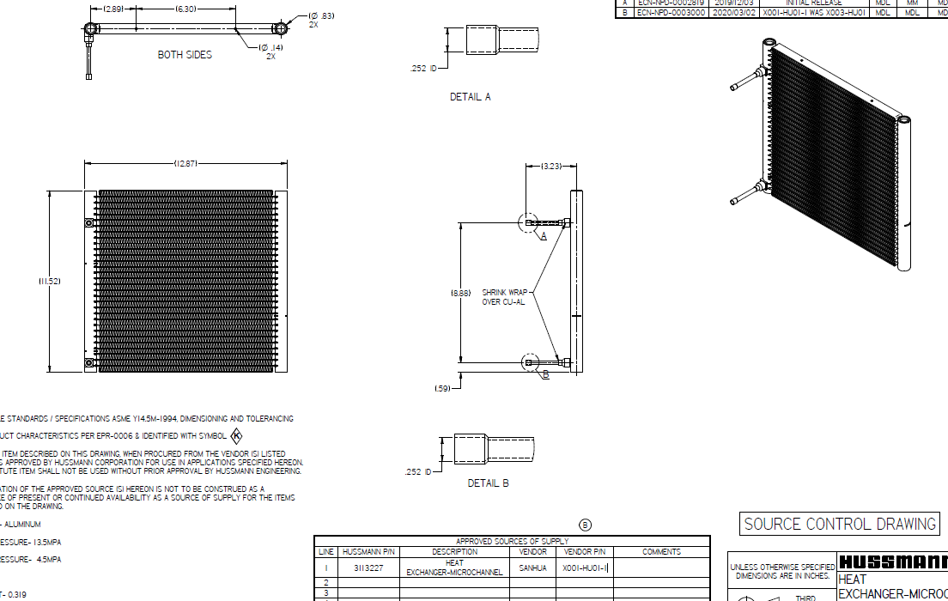
Yes, we can get a reasonable estimate from this drawing, although not an exact value because the tube count and tube ID are not explicitly shown.
From the drawing I can read:
- Core width = 12.87 in
- Core height = 11.52 in
- Header height ≈ 8.88 in
- Connections = 0.252 in ID
- Microchannel condenser with two vertical headers and horizontal ports
For a microchannel coil like this, most of the refrigerant volume is in:
- The two headers/manifolds
- The flat multi-port tubes
Header Volume
Assuming the header OD is about 0.83 in (dimension shown near the top view) and typical wall thickness:
- Header ID ≈ 0.70-0.75 in
- Length ≈ 8.88 in
For two headers:
0.070-0.080 L each ≈ 0.14-0.16 L total
Microchannel Tube Volume
For a condenser this size (about 13" × 11.5"), typical microchannel internal volume falls around:
0.12-0.20 L
depending on:
- Number of ports
- Port dimensions
- Number of passes
Total Internal Volume Estimate
Adding headers + tubes:
Total condenser volume ≈ 0.26-0.36 L
My best estimate from the drawing alone would be:
~0.30 L internal refrigerant volume (300 mL)
Converting to R290 Charge Held
Liquid R290 density near normal condensing conditions:
- ≈ 0.48-0.52 kg/L
For 0.30 L:
0.30 × 0.50 = 150 g R290
So if the condenser were completely liquid-filled, it could contain approximately:
130-180 g of R290
with ~150 g being a reasonable center estimate.
Interesting Check
Earlier you mentioned:
- System charge ≈ 110 g
- Evaporator inventory estimated around 4-12 g
- Model predicted most charge sits in the condenser
A condenser volume around 0.30 L actually supports that conclusion. An 0.30 L microchannel condenser could easily hold essentially the entire system charge as liquid during certain operating conditions.
If you have the Sanhua condenser datasheet or the number of flat tubes/ports visible in the CoilDesigner file, I can calculate the internal volume much more accurately, usually within ±10%.
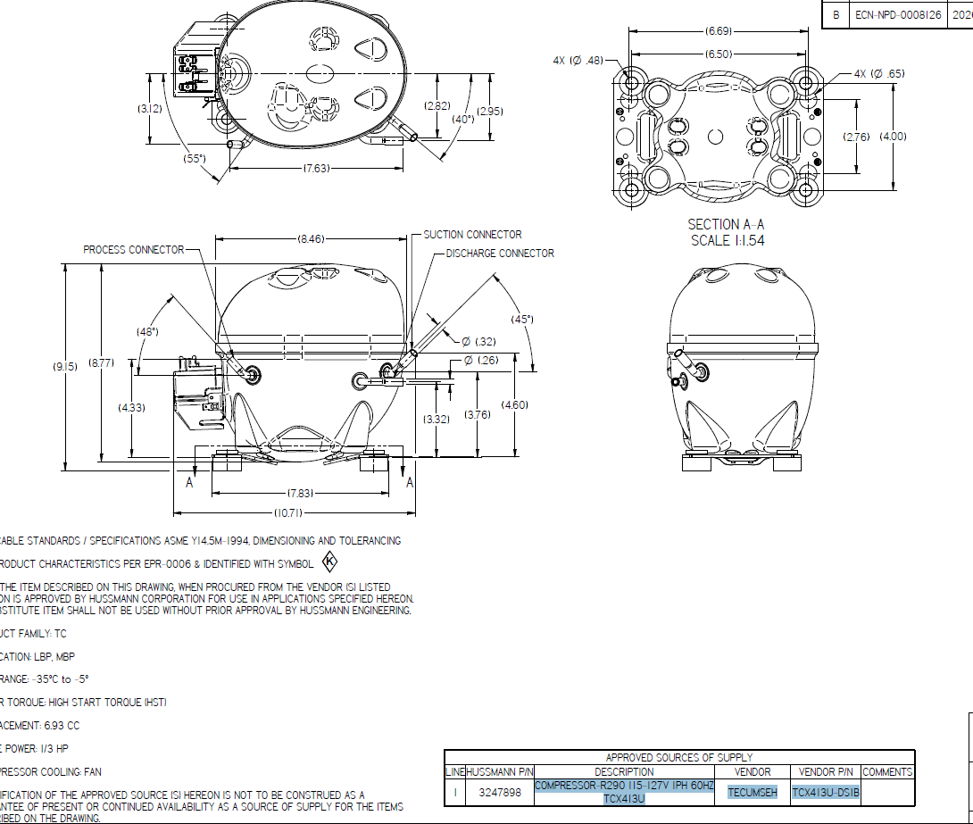
This drawing is actually very useful because it settles one question from the previous notes.
The compressor shown is:
- Tecumseh TCX413U
- R290
- LBP/MBP application
- Displacement = 6.93 cc/rev (visible on the drawing)
This means the assumption in the project notes that the compressor should be 20 cc/rev is almost certainly wrong for this unit.
What this means
The old notes stated:
Vs = 1.05e-5 → 2.0e-5 m³/rev
which corresponds to:
- 10.5 cc/rev → 20 cc/rev
But the drawing clearly shows:
6.93 cc/rev
Therefore the physically correct compressor displacement is:
Vs=6.93×10−6 m3/revV_s = 6.93 \times 10^{-6}\;m^3/revVs​=6.93×10−6m3/rev
not:
2.0×10−5 m3/rev2.0 \times 10^{-5}\;m^3/rev2.0×10−5m3/rev
and not even:
1.05×10−5 m3/rev1.05 \times 10^{-5}\;m^3/rev1.05×10−5m3/rev
Why this matters
Mass flow is approximately:
m˙∝Vs⋅ηv⋅N\dot m \propto V_s \cdot \eta_v \cdot Nm˙∝Vs​⋅ηv​⋅N
If the model is using 20 cc:
20/6.93=2.8920 / 6.93 = 2.8920/6.93=2.89
So the model would be predicting nearly 3× too much displacement before any efficiency corrections are applied.
That alone could explain:
- Capacity mismatch
- Charge distribution mismatch
- Incorrect suction/discharge pressures
- Incorrect evaporator loading
About Condenser Volume
Unfortunately this compressor drawing does not help determine condenser internal volume.
What it does help estimate is the compressor shell volume.
From the drawing:
- Shell roughly 8.5" high
- Body roughly 6.5-7" diameter
A compressor this size typically contains approximately:
- 0.4 to 0.7 L shell volume
- Much of that occupied by motor, spring assembly, oil, etc.
The actual refrigerant inventory inside the shell during operation is usually much less than the geometric volume.
My Main Takeaway
Of everything in the long "NEXT STEPS" report, the highest-risk assumption I see now is:
The model appears to have been built around a 20 cc compressor, while the actual drawing shows a 6.93 cc Tecumseh TCX413U.
Before spending more time refining condenser UA, TXV behavior, or charge distribution, I would verify the compressor model is using:
Displacement = 6.93 cc/rev (6.93e-6 m³/rev)
because that assumption has a much larger effect on mass flow and capacity than most of the remaining tuning items.
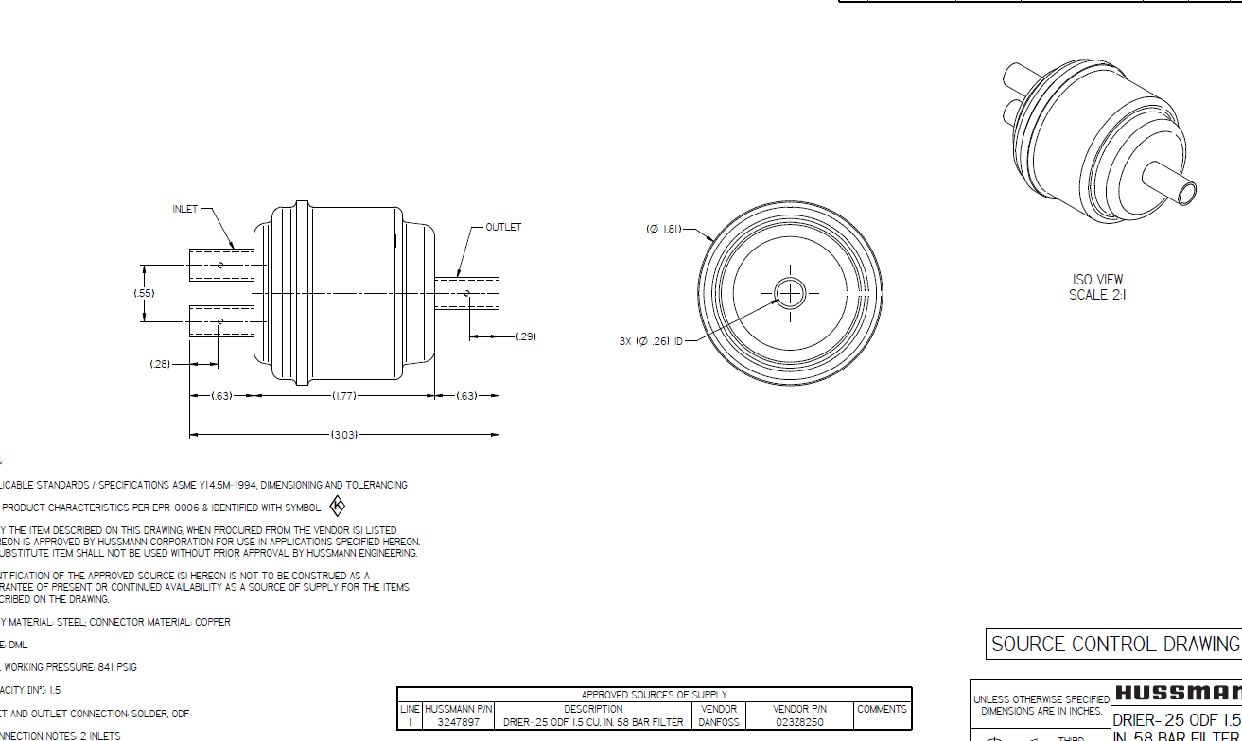
DRIER-.25 ODF 1.5 CU. IN. 58 BAR FILTER DANFOSS 023Z8250.

The Danfoss 023Z8250 is a DML 1.5 cu in liquid-line filter drier. Its internal shell volume is approximately 0.05 L (50 mL) and its net internal volume is approximately 0.034 L (34 mL).

If you're asking how much refrigerant it physically contains, that's roughly:

34 mL (0.034 L) internal refrigerant volume.
For liquid R448A/R449A/R404A type refrigerants (density ~1.0-1.1 kg/L), that's approximately 34-37 grams (1.2-1.3 oz) of liquid refrigerant. (Calculated from the published volume.)

For refrigeration system sizing, Danfoss rates this drier at about:

1.0 TR on R404A/R507A
1.4 TR on R134a
1.5 TR on R410A
1.7 TR on R290

So if you're trying to estimate refrigerant charge loss/recovery due to replacing the drier, I'd use ~35 g (1.2 oz) of liquid refrigerant in the drier itself, plus whatever liquid is trapped in the adjacent liquid line. That's usually a reasonable field estimate.

Tube lengths:
suction line about 40in long with 7 bends of various angles. 0.319 internal ID and 0.256 OD

liquid line - compressor through hot gas loop to 89inches to condenser.
liquid line - through solenoid 20in tube to coil. 0.194" id. 0.250 od

Wiring diagram:
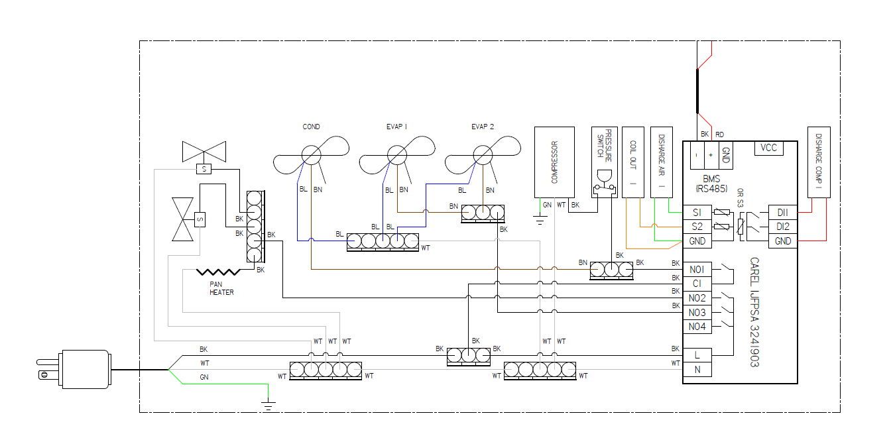

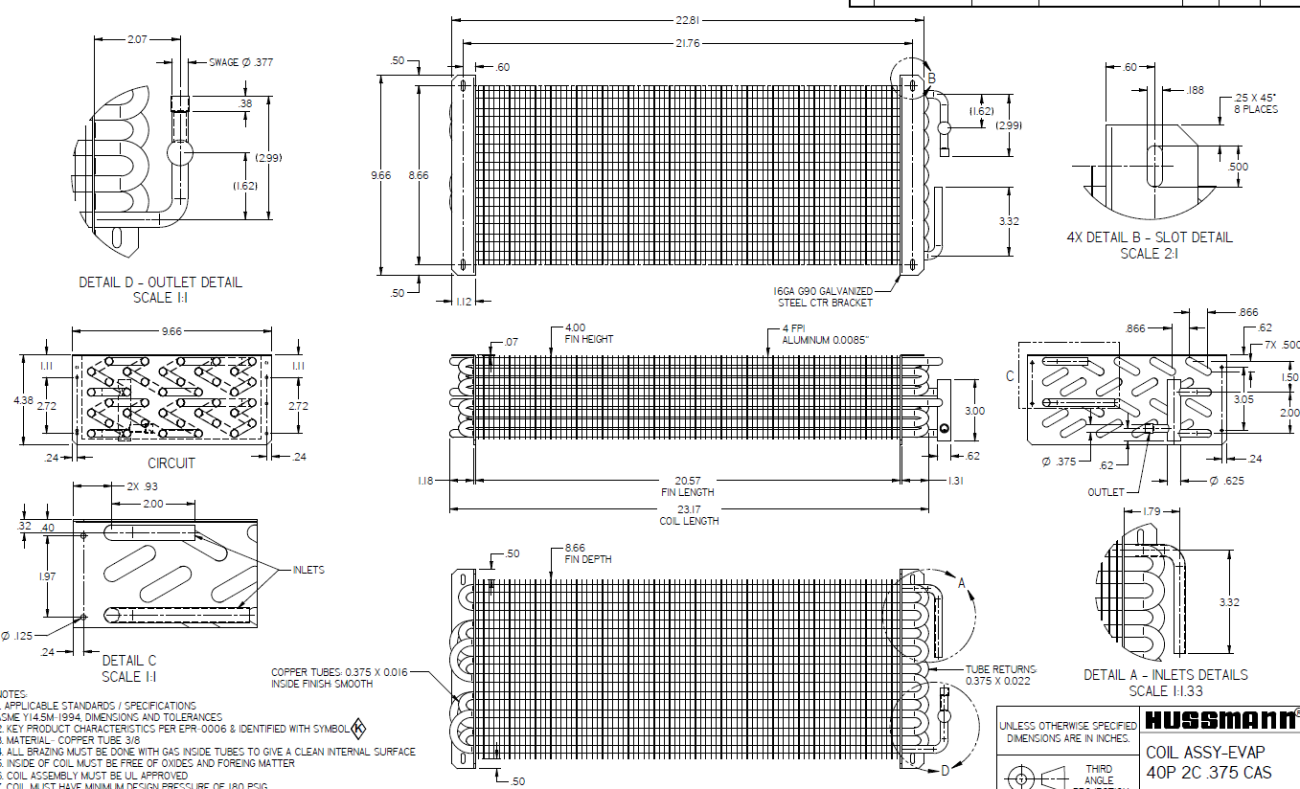

You’re right to keep this calculation strictly to the evaporator drawing. Based on the dimensions shown, the evaporator’s calculated tube-and-return volume is approximately 1.29 liters.
Information taken from the evaporator drawing
- Number of straight tube passes: 40
- Number of refrigerant circuits: 2
- Straight tube length: 20.57 in
- Straight tube outside diameter: 0.375 in
- Straight tube wall thickness: 0.016 in
- Return-bend outside diameter: 0.375 in
- Return-bend wall thickness: 0.022 in
- Tube spacing used for the return bend: 0.500 in
1. Straight-tube volume
Straight-tube inside diameter:
ID=0.375−2(0.016)=0.343 inID = 0.375-2(0.016)=0.343\text{ in}ID=0.375−2(0.016)=0.343 in
Inside cross-sectional area:
A=π4(0.343)2=0.09240 in2A=\frac{\pi}{4}(0.343)^2 =0.09240\text{ in}^2A=4π​(0.343)2=0.09240 in2
Total straight-tube length:
40×20.57=822.8 in40 \times 20.57=822.8\text{ in}40×20.57=822.8 in
Straight-tube internal volume:
V=822.8×0.09240=76.03 in3V=822.8 \times 0.09240 =76.03\text{ in}^3V=822.8×0.09240=76.03 in3 76.03 in3=1.246 L76.03\text{ in}^3=1.246\text{ L}76.03 in3=1.246 L
2. Return-bend volume
With two circuits and 20 tube passes per circuit, each circuit requires approximately 19 connections:
19×2=38 return bends19 \times 2=38\text{ return bends}19×2=38 return bends
Return-bend inside diameter:
ID=0.375−2(0.022)=0.331 inID=0.375-2(0.022)=0.331\text{ in}ID=0.375−2(0.022)=0.331 in
Assuming each return is approximately a semicircle with a 0.500-inch centerline diameter:
Lreturn=π×0.5002=0.785 inL_{\text{return}}=\frac{\pi \times 0.500}{2} =0.785\text{ in}Lreturn​=2π×0.500​=0.785 in
Total return-bend volume:
Vreturns≈2.57 in3=0.042 LV_{\text{returns}}\approx2.57\text{ in}^3 =0.042\text{ L}Vreturns​≈2.57 in3=0.042 L
Calculated evaporator volume
Vtotal=1.246+0.042V_{\text{total}}=1.246+0.042Vtotal​=1.246+0.042 Vevaporator≈1.288 L\boxed{V_{\text{evaporator}}\approx1.288\text{ L}}Vevaporator​≈1.288 L​
Recommended model value
Use:
Vevap=0.00129 m3\boxed{V_{\text{evap}}=0.00129\text{ m}^3}Vevap​=0.00129 m3​
or, if you want a rounded engineering value:
Vevap=1.3 L\boxed{V_{\text{evap}}=1.3\text{ L}}Vevap​=1.3 L​
This excludes the inlet distributor/manifold, outlet manifold, and external connection tubes because their complete internal dimensions are not available. Including those parts would likely make the actual volume slightly higher. A practical range is approximately 1.29 to 1.35 L.
The previous 1.05 L model value appears about 18% lower than the volume calculated directly from this drawing.

